SSH GitHub

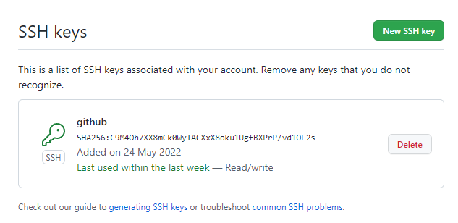

Recovery mode

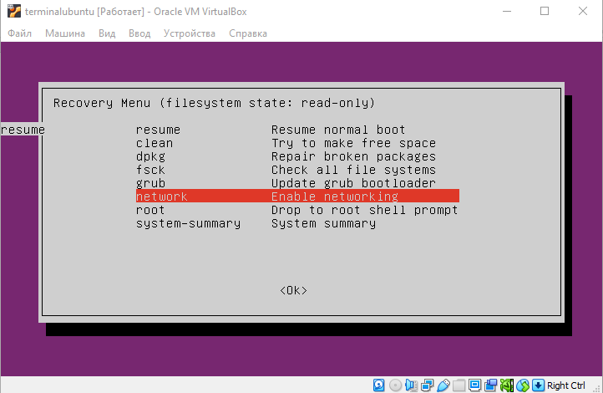

Ubuntu

Connect to Virtual Machines using SSH key, MOTD, change timezone and hostname

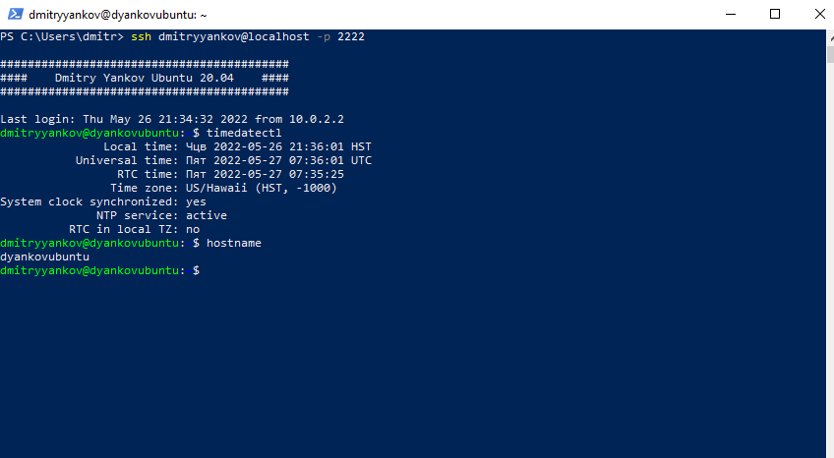

Kernel version and kernel modules

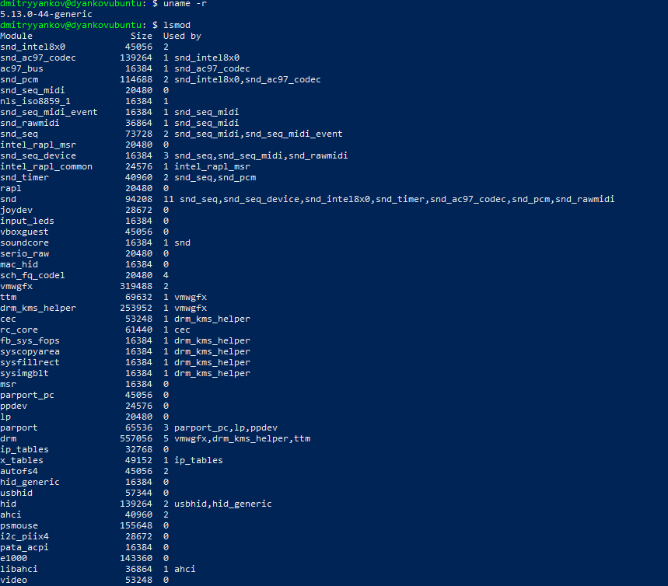

Hardware system information (CPU and Memory)

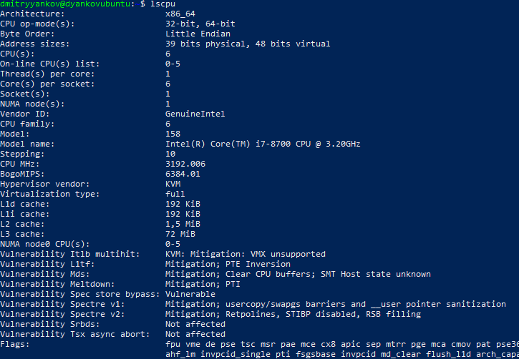

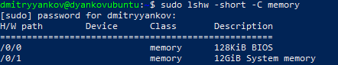

Information about hard drives

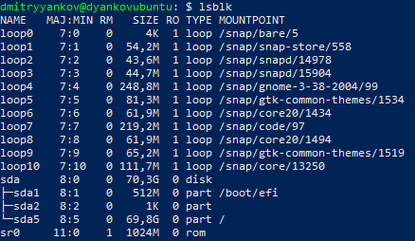

Information about PCIEx devices

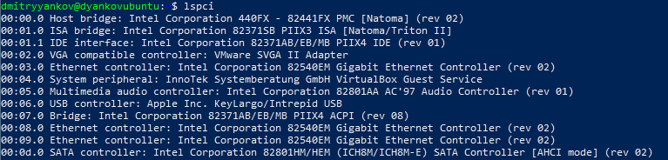

Network details (IP addresses and interfaces)

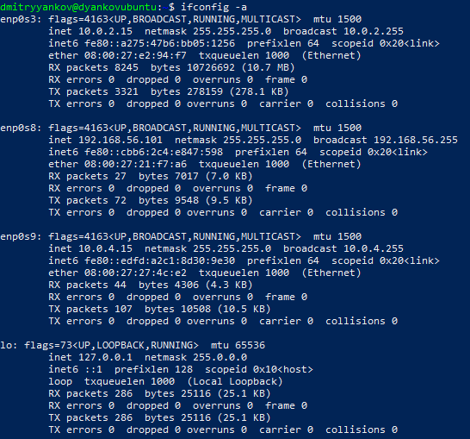

CentOS 8

Connect to Virtual Machines using SSH key, MOTD, change timezone and hostname

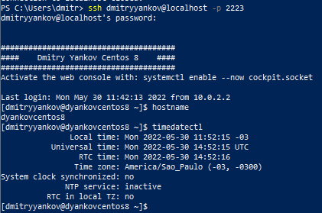

Kernel version and kernel modules

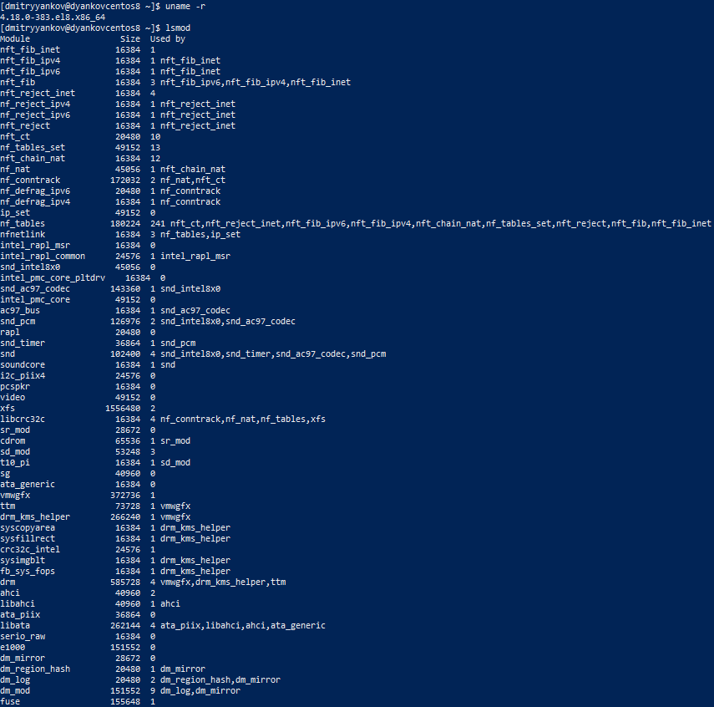

Hardware system information (CPU and Memory)

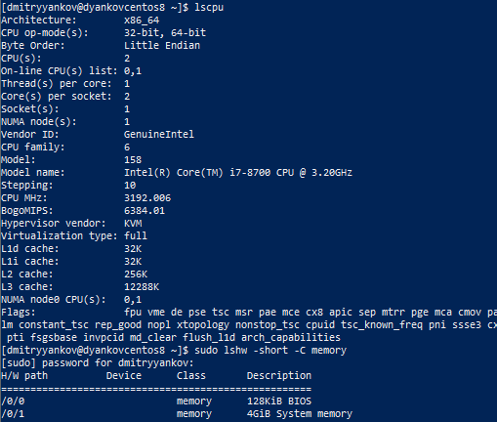

Information about hard drives

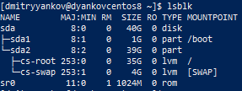

Information about PCIEx devices

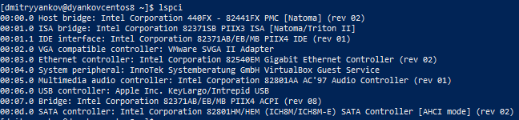

Network details (IP addresses and interfaces)

